 

INFRASTRUCTURE APPLICATION REQUIREMENTS -  
Excasso-Complex (VFV)

Version: 1.1

Date: *11-12-2023*

Based on Template: UWV REQ – TEMPLATE 2.0docx

## Table of Contents

Table of Contents 2

Document purpose: 3

Relation to other documents 4

Content of the document 4

Document change history 4

1 Application Overview 5

1.1 Introduction 5

1.2 Scope of the desired change 5

1.3 Application use cases 5

1.4 Out of scope 5

2 Architecture 6

2.1 Conceptual 6

2.2 Context diagram 7

3 Functional Requirements 23

4 Non-Functional Requirements 24

4.1 Security & Compliance classifications 24

4.2 System and Software requirements 24

4.3 Performance requirements 27

4.4 Security requirements 27

4.5 Backup and Recovery 27

4.6 Disaster Recovery 27

Appendix: Legenda Context Diagram 28

## Document purpose:

What is the Requirement document and why?

The requirement document is a Word document owned and managed by UWV.

The template of the requirement document can be found at this link: [Joined Collaboration Platform](https://dxcportalgbr.sharepoint.com/sites/UWVJCP/Delivery/Infrastructure/Forms/AllItems.aspx?RootFolder=%2Fsites%2FUWVJCP%2FDelivery%2FInfrastructure%2F00%5FInstructies%20en%20Templates%20%2D%20HLD%20en%20Requirements%20management&FolderCTID=0x012000E2656A960112194C951E9D08878546D9&View=%7B325BC795%2D92C8%2D49C8%2D9509%2D5F65CBCD32A3%7D) If you cannot access the link, ask access to [jcp@uwv.nl](mailto:jcp@uwv.nl)

If a business division would like to :

1. implement a new CI (application)
2. modifiy an existing CI (for example an upgrade of a server, a new connection request, a new functionality, a new component, a new server, etc.)

Then the business division (using the template) should fill-in the requirements, which will be reviewed according to the “HLD Fabriek” process.

Special requests – as exceptions – could be handled outside the “HLD Fabriek” process.

Once the requirement document will be filled-in for a new/existing CI, the business division which owns the CI will become also the owner of the requirement document, also for future versions and changes.

Why the requirement document is important ?

1. The requirement document is a collection of wishes and requirements from the business division to the leverancier DXC.

The document contains requirements:

on hosting (hardware, software) level

on security en compliancy level

on network level (connections)

on functionality level (use cases)

on performance level

and it will be used by DXC to:

* Gain a general understanding of the application requirements
* Deliver the Infrastructure Application design (IA HLD): after the validation of the HLD by the UWV Technical Design autority (TDA) a “building permit”or “Bouwvergunning” is issued by the TDA. That is the starting point for projects realization phase. For more info on the TDA please turn to the ICT Services Lead Architect.

1. The requirement document is also important because it has a contractual relevance

Why the requirement document must be written in English ?

Because the Requirement document and the HLD are considered technical documents and DXC is a global company with employees from all over the world, thus English is the official language.

Name of this requirement document

The name of this requirement document = name of the application (CI).

A correct application name must be used, consistent with confipedia (use exact full name, case sensitive). Link to site: [Confipedia](https://samenwerken.sharepoint.uwv.nl/sites/ict/pm/config/basl%20html/index.html)

In case this document describes a cluster of applications, each application must be mentioned here separately

Contact:

If you have questions, feedbacks or remarks regarding this template, please contact ict.ior_applicatiehosting@uwv.nl

## Relation to other documents

The following documents may be relevant as context to this REQ:

* The Software Architecture Document (SAD). If available deliver the SAD as a separate document.
* The Project Start Architecture (PSA) document

Infrastructure Application design produced by DXC for related applications (interfaces)

## Content of the document

UWV has prepared this document in good faith and is based on the information gathered during the requirement determination phase with all parties involved; application vendors, UWV architects, developers and UWV functional management.

## Document change history

Please note:

For brand new applications: UWV needs to deliver to DXC a “major” version 1.0

For existing applications (already implemented in production for example) UWV needs to deliver to DXC a new, updated version of the requirement document.

|  |  |  |  |
| --- | --- | --- | --- |
| Version | Date | Author | Summary of Changes |
| 1.0 | 30-10-2023 | C.Brouwer | Created based on HLD v1.2 |
| 1.1 | 11-12-2023 | U. Can | Adjusted based on HLD v1.3 and Req Temp v1.0 |
|  |  |  |  |

# Application Overview

## Introduction

VFV (Excasso); Excasso Complex consists of several subsystems that perform specific tasks, which can be found in paragraph 2.1.

Gross/Net systems: The excasso application processes all Gross and Net requests from several claiming systems into a ´rekening courant´ claim or payments. Built-in functionalities are able to handle the financial functionalities automatically.

Claims (´Invorderingen´ or INV): Registers internal and external claims (claims by third parties).

RPO (´Regio Personeel en Organisatie´): Records the organisation diagrams and officials.

GEM (´Gemeenschappelijke fiscale persoonsgegevens´): Stores fiscal details which are consulted and used for verification of each payment.

EBH (´Excasso Boekhouding´): Contains and maintains the definitions of journal entries. EBH receives booking rules from the various subsystems and translates these to journal entries which are transferred to the financial administration (PeopleSoft).

BSU (´Betaling Systeem UWV Bouwnijverheid´): Automated, daily payments to insured or third parties.

ALIS (´Algemeen Loonbelasting InformatieSysteem´): Performs the fiscal information provision to the tax company.

SBS & OBS (replacing the current FBS application). SBS is an application designed to mutate the control tables for Excasso in all domains (OTAP). OBS is an application designed to mutate the other tables for Excasso in their respected domain only.

## Scope of the desired change

Please insert a clear description of the desired change

## Application use cases

Application use cases are defined in 1.1.

## Out of scope

All components that belong to the UWV Office Infrastructure such as workstations, web browsers are out of scope.

# Architecture

## Conceptual

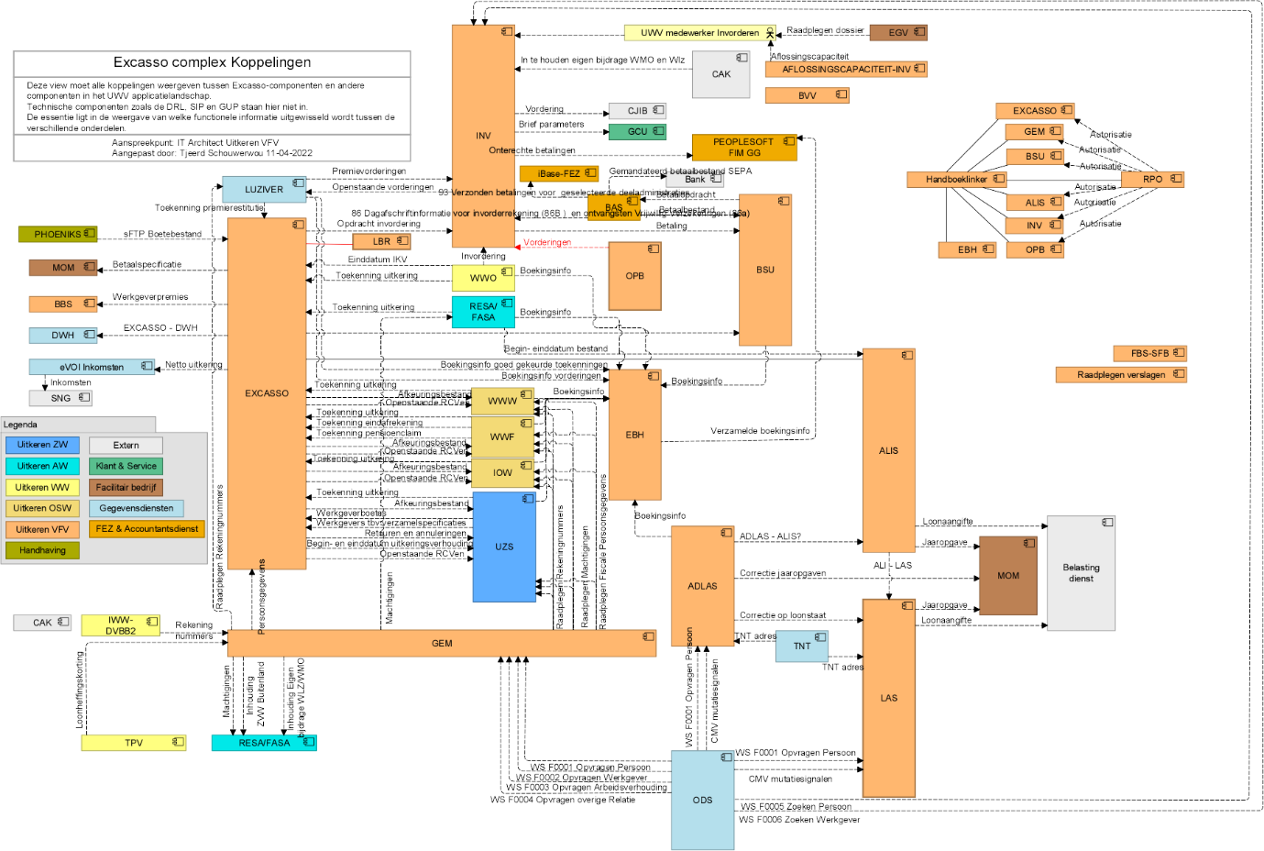

## Context diagram

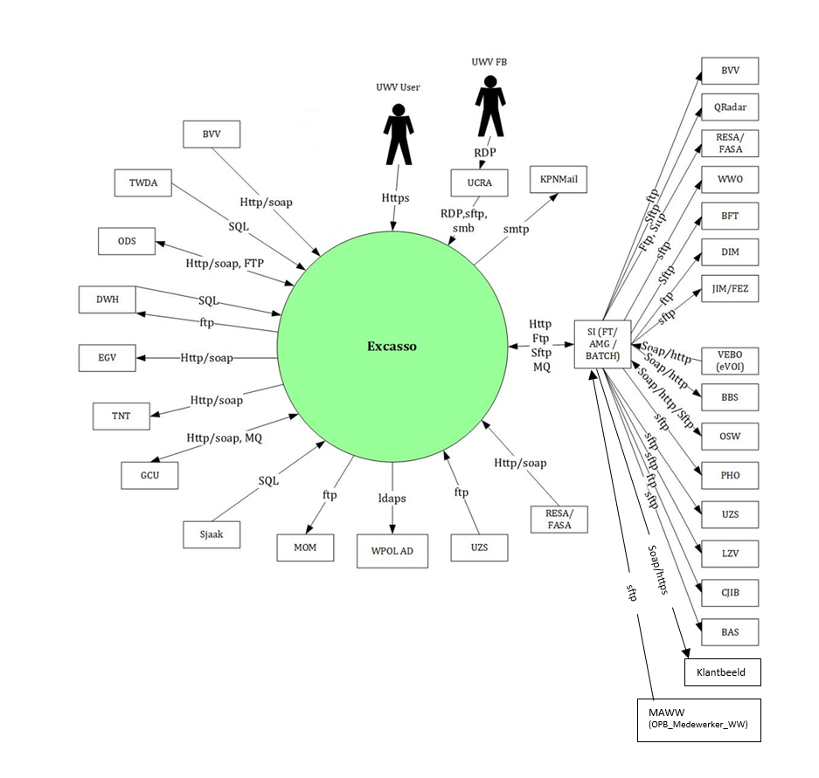

### External entities

#### UWV User

|  |  |
| --- | --- |
| **Description** | End users of the Excasso Complex frontend application via KA Werkplek using Browser |
| **Protocol and Port** | HTTPS:443 |
| **DC (Datacenter) connection** | External |
| **Direction** | Inbound |
| **Direct connection** | Yes |
| **Security Controls** | Authorisation method or authentication method: RBAC (AD) &OAM  Use certificates: Yes (External CA) Entrust /PKI overheid  Service account: Select (mandatory)  Other: <(only mention if applicable) other applicable security control related configuration> |
| **Number of users** | 1000+ |
| **Number of transactions** | not specified |
| **Frequency of transactions** | not specified |
| **Volume of data** | not specified |

#### UWV FB

|  |  |
| --- | --- |
| **Description** | Functional maintenance of the Excasso Complex frontend application using the UCRA environment |
| **Protocol and Port** | RDP: 3389 | (s)FTP: port 20,21,22 | SMB:445 |
| **DC (Datacenter) connection** | Internal |
| **Direction** | Inbound |
| **Direct connection** | Yes |
| **Security Controls** | Authorisation method or authentication method: RBAC (AD)  Use certificates: Select (mandatory)  Service account: Select (mandatory)  Other: Uses Private/Public Keys for sftp connections |
| **Number of users** | 5+ |
| **Number of transactions** | not specified |
| **Frequency of transactions** | not specified |
| **Volume of data** | not specified |

#### AD / WPOL

|  |  |
| --- | --- |
| **Description** | Connection to the KPN AD Wpol for verification of users entered in the ABS |
| **Protocol and Port** | LDAPS:636 |
| **DC (Datacenter) connection** | External |
| **Direction** | Outbound |
| **Direct connection** | Yes |
| **Security Controls** | Authorisation method or authentication method: S2S (mandatory)  Use certificates: Select (mandatory)  Service account: Select (mandatory)  Other: <(only mention if applicable) other applicable security control related configuration>  Uses Private/Public Keys for sftp connections |
| **Number of users** | Not specified |
| **Number of transactions** | Not specified |
| **Frequency of transactions** | Not specified |
| **Volume of data** | Not specified |

#### BAS

|  |  |
| --- | --- |
| **Description** | Betalingenbestand, retour betalingen |
| **Protocol and Port** | SFTP:21 |
| **DC (Datacenter) connection** | Internal |
| **Direction** | Outbound |
| **Direct connection** | No  Via: SI |
| **Security Controls** | Authorisation method or authentication method: S2S  Use certificates: Select (mandatory)  Service account: Select (mandatory)  Other: <(only mention if applicable) other applicable security control related configuration> |
| **Number of users** | Not specified |
| **Number of transactions** | Not specified |
| **Frequency of transactions** | Not specified |
| **Volume of data** | Not specified |

#### MAWW

|  |  |
| --- | --- |
| **Description** | Ophalen/verwijderen machtigingen aangeleverd door MAWW |
| **Protocol and Port** | SFTP:22 |
| **DC (Datacenter) connection** | Internal |
| **Direction** | Outbound |
| **Direct connection** | No (mandatory field)  Via: SI |
| **Security Controls** | Authorisation method or authentication method: S2S  Use certificates: Select (mandatory)  Service account: Select (mandatory)  Other: public- en privatkey |
| **Number of users** | Not specified |
| **Number of transactions** | Not specified |
| **Frequency of transactions** | Not specified |
| **Volume of data** | Not specified |

#### BVV

|  |  |
| --- | --- |
| **Description** | Opsturen bestand, ophalen beslagvrije voet via XML, registreren modelmededeling |
| **Protocol and Port** | sFTP:22, Soap/Https:443 |
| **DC (Datacenter) connection** | Internal |
| **Direction** | Inbound and Outbound |
| **Direct connection** | Yes for Soap (Inbound)  No Via: SI for SFTP (Outbound) |
| **Security Controls** | Authorisation method or authentication method: S2S  Use certificates: Select (mandatory)  Service account: Select (mandatory)  Other: Public/Private key |
| **Number of users** | Not specified |
| **Number of transactions** | Not specified |
| **Frequency of transactions** | Not specified |
| **Volume of data** | Not specified |

#### CJIB

|  |  |
| --- | --- |
| **Description** | Sending and Receiving XML notices |
| **Protocol and Port** | FTP:21 |
| **DC (Datacenter) connection** | Internal |
| **Direction** | Inbound and Outbound |
| **Direct connection** | No  Via: SI |
| **Security Controls** | Authorisation method or authentication method: S2S  Use certificates: Select (mandatory)  Service account: Yes  Other: <(only mention if applicable) other applicable security control related configuration> |
| **Number of users** | Not specified |
| **Number of transactions** | Not specified |
| **Frequency of transactions** | Not specified |
| **Volume of data** | Not specified |

#### DWH

|  |  |
| --- | --- |
| **Description** | DataWareHouse + DWH BO Business Objects |
| **Protocol and Port** | FTP:21, SQL*Net:1526 |
| **DC (Datacenter) connection** | Internal |
| **Direction** | Inbound and Outbound |
| **Direct connection** | Yes |
| **Security Controls** | Authorisation method or authentication method: S2S  Use certificates: Select (mandatory)  Service account: Yes  Other: <(only mention if applicable) other applicable security control related configuration> |
| **Number of users** | Not specified |
| **Number of transactions** | Not specified |
| **Frequency of transactions** | Not specified |
| **Volume of data** | Not specified |

#### EGV

|  |  |
| --- | --- |
| **Description** | Raadplegen Dossier |
| **Protocol and Port** | SOAP/HTTPS:443 |
| **DC (Datacenter) connection** | Internal |
| **Direction** | Outbound |
| **Direct connection** | Yes |
| **Security Controls** | Authorisation method or authentication method: S2S  Use certificates: Select (mandatory)  Service account: Select (mandatory)  Other: <(only mention if applicable) other applicable security control related configuration> |
| **Number of users** | Not specified |
| **Number of transactions** | Not specified |
| **Frequency of transactions** | Not specified |
| **Volume of data** | Not specified |

#### JIM/FEZ

|  |  |
| --- | --- |
| **Description** | Leveren Boekhoudinformatie |
| **Protocol and Port** | SFTP:22 |
| **DC (Datacenter) connection** | Internal |
| **Direction** | Outbound |
| **Direct connection** | No  Via: SI |
| **Security Controls** | Authorisation method or authentication method: S2S  Use certificates: Select (mandatory)  Service account: Select (mandatory)  Other: Public, Privatekey |
| **Number of users** | Not specified |
| **Number of transactions** | Not specified |
| **Frequency of transactions** | Not specified |
| **Volume of data** | Not specified |

#### GCU

|  |  |
| --- | --- |
| **Description** | Brief Parameters |
| **Protocol and Port** | SOAP/HTTP:80, MQ:7501 |
| **DC (Datacenter) connection** | Internal |
| **Direction** | Inbound and Outbound |
| **Direct connection** | Yes |
| **Security Controls** | Authorisation method or authentication method: S2S  Use certificates: Select (mandatory)  Service account: Select (mandatory)  Other: <(only mention if applicable) other applicable security control related configuration> |
| **Number of users** | Not specified |
| **Number of transactions** | Not specified |
| **Frequency of transactions** | Not specified |
| **Volume of data** | Not specified |

#### OSW

|  |  |
| --- | --- |
| **Description** | Combination of WWF, IOW, WWW |
| **Protocol and Port** | FTP:21, SFTP:22, SOAP/HTTPS:443 |
| **DC (Datacenter) connection** | Internal |
| **Direction** | Inbound and Outbound |
| **Direct connection** | No  Outbound via SI (FTP, SFTP)  No  Inbound via SI (SOAP). |
| **Security Controls** | Authorisation method or authentication method: S2S  Use certificates: Select (mandatory)  Service account: Yes  Other: Private/Publickey |
| **Number of users** | Not specified |
| **Number of transactions** | Not specified |
| **Frequency of transactions** | Not specified |
| **Volume of data** | Not specified |

#### WWO

|  |  |
| --- | --- |
| **Description** | WerkloosheidsWet Ontslag |
| **Protocol and Port** | SFTP:22 |
| **DC (Datacenter) connection** | Internal |
| **Direction** | Outbound |
| **Direct connection** | No  Via: SI (SFTP) |
| **Security Controls** | Authorisation method or authentication method: S2S  Use certificates: Select (mandatory)  Service account: Yes  Other: Private/Publickey |
| **Number of users** | Not specified |
| **Number of transactions** | Not specified |
| **Frequency of transactions** | Not specified |
| **Volume of data** | Not specified |

#### QRadar

|  |  |
| --- | --- |
| **Description** | Lomo, delivering data to QRadar. Storing Transactions. |
| **Protocol and Port** | SFTP:22 |
| **DC (Datacenter) connection** | Internal |
| **Direction** | Outbound |
| **Direct connection** | No  Via: SI |
| **Security Controls** | Authorisation method or authentication method: S2S  Use certificates: Select (mandatory)  Service account: Select (mandatory)  Other: Private/Publickey |
| **Number of users** | Not specified |
| **Number of transactions** | Not specified |
| **Frequency of transactions** | Not specified |
| **Volume of data** | Not specified |

#### LZV

|  |  |
| --- | --- |
| **Description** | Luziver |
| **Protocol and Port** | SFTP:22 |
| **DC (Datacenter) connection** | Internal |
| **Direction** | Outbound |
| **Direct connection** | No  Via: SI |
| **Security Controls** | Authorisation method or authentication method: S2S  Use certificates: Select (mandatory)  Service account: Select (mandatory)  Other: Private/Publickey |
| **Number of users** | Not specified |
| **Number of transactions** | Not specified |
| **Frequency of transactions** | Not specified |
| **Volume of data** | Not specified |

#### KPNMail

|  |  |
| --- | --- |
| **Description** | KPN Mail Relay |
| **Protocol and Port** | SMTP:25 |
| **DC (Datacenter) connection** | External |
| **Direction** | Outbound |
| **Direct connection** | Yes |
| **Security Controls** | Authorisation method or authentication method: S2S  Use certificates: Select (mandatory)  Service account: Select (mandatory)  Other: <(only mention if applicable) other applicable security control related configuration> |
| **Number of users** | Not specified |
| **Number of transactions** | Not specified |
| **Frequency of transactions** | Not specified |
| **Volume of data** | Not specified |

#### ODS

|  |  |
| --- | --- |
| **Description** | Operational DataStore |
| **Protocol and Port** | SOAP/HTTP:80, FTP:21 |
| **DC (Datacenter) connection** | Internal |
| **Direction** | Inbound and Outbound |
| **Direct connection** | Yes |
| **Security Controls** | Authorisation method or authentication method: S2S (mandatory)  Use certificates: Select (mandatory)  Service account: Select (mandatory)  Other: <(only mention if applicable) other applicable security control related configuration> |
| **Number of users** | Not specified |
| **Number of transactions** | Not specified |
| **Frequency of transactions** | Not specified |
| **Volume of data** | Not specified |

#### PHO

|  |  |
| --- | --- |
| **Description** | Phoeniks, Handhaving (Fraud) |
| **Protocol and Port** | SFTP:22 |
| **DC (Datacenter) connection** | Internal |
| **Direction** | Outbound |
| **Direct connection** | No  Via: SI |
| **Security Controls** | Authorisation method or authentication method: S2S  Use certificates: Select (mandatory)  Service account: Select (mandatory)  Other: Public/Privatekey |
| **Number of users** | Not specified |
| **Number of transactions** | Not specified |
| **Frequency of transactions** | Not specified |
| **Volume of data** | Not specified |

#### ResaFasa

|  |  |
| --- | --- |
| **Description** | ReSaFaSa |
| **Protocol and Port** | SOAP/HTTP:80, FTP:21, SFTP:22 |
| **DC (Datacenter) connection** | Internal |
| **Direction** | Inbound and Outbound |
| **Direct connection** | Yes (Inbound)  No  Via: SI (Outbound) |
| **Security Controls** | Authorisation method or authentication method: S2S  Use certificates: Select (mandatory)  Service account: Yes  Other: Private/Publickey |
| **Number of users** | Not specified |
| **Number of transactions** | Not specified |
| **Frequency of transactions** | Not specified |
| **Volume of data** | Not specified |

#### TNT

|  |  |
| --- | --- |
| **Description** | Postcode Tabel |
| **Protocol and Port** | SOAP/HTTP:80 |
| **DC (Datacenter) connection** | External |
| **Direction** | Outbound |
| **Direct connection** | Yes |
| **Security Controls** | Authorisation method or authentication method: S2S  Use certificates: Select (mandatory)  Service account: Select (mandatory)  Other: <(only mention if applicable) other applicable security control related configuration> |
| **Number of users** | Not specified |
| **Number of transactions** | Not specified |
| **Frequency of transactions** | Not specified |
| **Volume of data** | Not specified |

#### UZS

|  |  |
| --- | --- |
| **Description** | Ziektewet Systeem |
| **Protocol and Port** | FTP:21, SFTP:22 |
| **DC (Datacenter) connection** | Internal |
| **Direction** | Inbound and Outbound |
| **Direct connection** | Yes  No  Via: SI |
| **Security Controls** | Authorisation method or authentication method: S2S  Use certificates: Select (mandatory)  Service account: Yes (mandatory)  Other: Private/Publickey |
| **Number of users** | Not specified |
| **Number of transactions** | Not specified |
| **Frequency of transactions** | Not specified |
| **Volume of data** | Not specified |

#### BFT

|  |  |
| --- | --- |
| **Description** | Belastingdienst FileTransfer |
| **Protocol and Port** | SFTP:22 |
| **DC (Datacenter) connection** | Internal |
| **Direction** | Outbound |
| **Direct connection** | No  Via: SI |
| **Security Controls** | Authorisation method or authentication method: S2S (mandatory)  Use certificates: Select (mandatory)  Service account: Yes (mandatory)  Other: Private/Publickey |
| **Number of users** | Not specified |
| **Number of transactions** | Not specified |
| **Frequency of transactions** | Not specified |
| **Volume of data** | Not specified |

#### DIM

|  |  |
| --- | --- |
| **Description** | Datafabriek, sending of a weekly manual created parfile by TAB |
| **Protocol and Port** | FTP:21 |
| **DC (Datacenter) connection** | Internal |
| **Direction** | Outbound |
| **Direct connection** | No  Via: SI |
| **Security Controls** | Authorisation method or authentication method: S2S  Use certificates: Select (mandatory)  Service account: Yes  Other: Private/Publickey |
| **Number of users** | Not specified |
| **Number of transactions** | Not specified |
| **Frequency of transactions** | Not specified |
| **Volume of data** | Not specified |

#### VEBO (eVOI)

|  |  |
| --- | --- |
| **Description** | VEBO (Uitkeringsbeslagen Personen) |
| **Protocol and Port** | SOAP/HTTP:80 |
| **DC (Datacenter) connection** | Internal |
| **Direction** | Inbound |
| **Direct connection** | No  Via: SI |
| **Security Controls** | Authorisation method or authentication method: S2S  Use certificates: Select (mandatory)  Service account: Select (mandatory)  Other: <(only mention if applicable) other applicable security control related configuration> |
| **Number of users** | Not specified |
| **Number of transactions** | Not specified |
| **Frequency of transactions** | Not specified |
| **Volume of data** | Not specified |

#### Klantbeeld

|  |  |
| --- | --- |
| **Description** | GUP service EXC KB V0100 http: aanvragen klantbeeld |
| **Protocol and Port** | https:443 |
| **DC (Datacenter) connection** | Internal |
| **Direction** | Outbound |
| **Direct connection** | Yes |
| **Security Controls** | Authorisation method or authentication method: S2S  Use certificates: Select (mandatory)  Service account: Select (mandatory)  Other: <(only mention if applicable) other applicable security control related configuration> |
| **Number of users** | Not specified |
| **Number of transactions** | Not specified |
| **Frequency of transactions** | Not specified |
| **Volume of data** | Not specified |

#### BBS

|  |  |
| --- | --- |
| **Description** | BBS, Opvragen Werkgeverspremie |
| **Protocol and Port** | SOAP/HTTP:80 |
| **DC (Datacenter) connection** | Internal |
| **Direction** | Outbound |
| **Direct connection** | No  Via: SI |
| **Security Controls** | Authorisation method or authentication method: S2S (mandatory)  Use certificates: Select (mandatory)  Service account: Select (mandatory)  Other: <(only mention if applicable) other applicable security control related configuration> |
| **Number of users** | Not specified |
| **Number of transactions** | Not specified |
| **Frequency of transactions** | Not specified |
| **Volume of data** | Not specified |

#### MOM

|  |  |
| --- | --- |
| **Description** | Printing Jaaropgave and correctie Jaaropgave |
| **Protocol and Port** | FTP:21 |
| **DC (Datacenter) connection** | External |
| **Direction** | Outbound |
| **Direct connection** | Yes |
| **Security Controls** | Authorisation method or authentication method: S2S  Use certificates: Select (mandatory)  Service account: Select (mandatory)  Other: <(only mention if applicable) other applicable security control related configuration> |
| **Number of users** | Not specified |
| **Number of transactions** | Not specified |
| **Frequency of transactions** | Not specified |
| **Volume of data** | Not specified |

#### TWDA

|  |  |
| --- | --- |
| **Description** | TWDA access to Query Database, for reporting purposes |
| **Protocol and Port** | SQL*Net: 1526 |
| **DC (Datacenter) connection** | Internal |
| **Direction** | Inbound |
| **Direct connection** | Yes |
| **Security Controls** | Authorisation method or authentication method: Select (mandatory) (Local database user / password)  Use certificates: Select (mandatory)  Service account: Select (mandatory)  Other: <(only mention if applicable) other applicable security control related configuration> |
| **Number of users** | Not specified |
| **Number of transactions** | Not specified |
| **Frequency of transactions** | Not specified |
| **Volume of data** | Not specified |

#### Sjaak

|  |  |
| --- | --- |
| **Description** | Monitoring of timedifference between database and logical standby database (querydatabase) |
| **Protocol and Port** | SQL*Net: 1526 |
| **DC (Datacenter) connection** | External |
| **Direction** | Inbound |
| **Direct connection** | Yes |
| **Security Controls** | Authorisation method or authentication method: Select (mandatory) (Local database user / password)  Use certificates: Select (mandatory)  Service account: Select (mandatory)  Other: <(only mention if applicable) other applicable security control related configuration> |
| **Number of users** | Not specified |
| **Number of transactions** | Not specified |
| **Frequency of transactions** | Not specified |
| **Volume of data** | Not specified |

# Functional Requirements

No functional requirements specified.

# Non-Functional Requirements

## Security & Compliance classifications

Repository used is: <specify the year, see description>…

[BIV classificatie 2.0](https://samenwerken.sharepoint.uwv.nl/sites/DWU/ConcernICT/IBenP/CISO-Office/SiteAssets/SitePages/4.%25)

For the BIV Rating the advice of the “Coördinator informatiebeveiliging en privacy” is followed according to the latest ISRA (Information Security Risk Assessment).

|  |  |
| --- | --- |
| **Application** | Excasso Complex |
| **Owner** | Uitkeren |
| **Availability (Beschikbaarheid)** | 3 |
| **Integrity (Integriteit)** | 2 |
| **Confidentiality (Vertrouwelijkheid)** | 3 |
| **Type of information /Data Classification** | Financiële grote geldstromen |

### Applicable security and compliance frameworks

|  |  |  |
| --- | --- | --- |
| Security & Compliance Framework | Applicable | Comments |
| BIR 2017 | Yes | If Not Applicable (Not compliant) please explain |
| AVG / GDPR | Yes | Only select No if no personal data is handled. GPDR is mandatory in all other cases |
| DIGID | No |  |
| SUWI | No |  |
| Additional frameworks | No additional security or compliance Frameworks |  |

## System and Software requirements

### Private Cloud system

#### System (Operating system (OS))

| **Server(type)** | **Operating System** | **Version** |
| --- | --- | --- |
| <example: Database server 1> | Windows | 2016 |
|  | RedHat Enterprise | 8.x |
|  | AIX | 7.2 |

#### System capacity forecast (volumetrics)

About 6000 users are registered in ABS to wpol group “BPB_menu_fa”, this means at most 6000 concurrent users will be able to use the Excasso application.

| **Server(type)** | **vCPU** | **RAM (GB)** | **Data Storage (GB)**  Data storage size for the OS is fixed |
| --- | --- | --- | --- |
| <example: Database server 1> |  |  |  |
|  |  |  |  |

#### Availability

|  |  |  |  |  |
| --- | --- | --- | --- | --- |
| **Environment** | **Application Target** | **Application Service Hours** | **Infra Target** | **Infra Service Hours** |
| Production | 99,8% | 7 x 24 | 99,8% | 7 x 24 |
| Acceptance | 98% | 5 x 12 (Mo-Fr, 7 - 19h) | 99,5% | 5 x 12 (Mo-Fr, 7 - 19h) |
| Education on Acceptance | 98% | 5 x 12 (Mo-Fr, 7 - 19h) | 98% | 5 x 12 (Mo-Fr, 7 - 19h) |
| Test | 98% | 5 x 12 (Mo-Fr, 7 - 19h) | 98% | 5 x 12 (Mo-Fr, 7 - 19h) |

#### Storage replication

|  |  |
| --- | --- |
| **Environment** | **Storage Replication** |
| Production | Replicated storage |
| Acceptance | Replicated storage |
| Education (Acceptance) | Non-replicated storage |
| Test | Non-replicated storage |

#### Scalability

The design should allow for upscaling of resources in order to improve performance. The initial systems setup will be vertically and horizontally scalable.

Scalability limitations for the application are not defined, not applicable, or unknown to DXC.

| **Server(type)** | **Scalability type** | **Additional Comments** |
| --- | --- | --- |
| <example: server 1> | Kies een item. |  |
| <example: server 2> | Kies een item. |  |

In case of infra load balancer, specify requirements:

Load balancer infra requirements

|  |  |
| --- | --- |
| **Application Layer** | HTTP (L7) |
| **Application Port(s)** | 80 |
| **Algorithm** | Least Connections (default) |
| **Stickiness/Persistence** | None |
| **Health monitor type** | System-HTTP |

Please note: the default algorithm is: Least connections. Do not deviate from this, unless theres is a specific reason.

#### Software (Licenses)

| **Server(type)** | **Software product / component** | **Version** |
| --- | --- | --- |
| <example:Database server 1> | IBM XL C FOR AIX | 16.1 |
|  | IBM JAVA SE | 8 |
|  | ORACLE DATABASE | 12cr2 |
|  | MICROFOCUS ACUCOBOL-GT EXTEND | 10.5 |

#### System management

No additional system management requirements have been provided.

#### Additional application related infra requirements

|  |  |
| --- | --- |
| **Requirements** | **Status** |
| Use STARTTLS option for UWV mail | No |
| Is Microsoft DTC used for inflight transactions | No |
| Is HTTPS cookie stickiness required on the load balancer | No |

Please note:

1 UWV mail (The internal KPN mailrelay's for UWV (uwvmailrelay.voorzieningen.uwv.nl, prt 25) is equipped with the STARTTLS option.

This means that every application server can now send the SMTP messages encrypted if desired. STARTTLS is based on negotiation. TLS is not mandatory but is preferred. Mail clients that do not want or cannot use TLS can continue to send mail.  The TLS version used is TLS V1.2. To enable TLS, systems must be provided with Digicert's root and intermediate certificates. This is a public CA that appears in all common certificate stores.

2 In case SQL AOAG (Always On Availability Groups) is used, then MSDTC (Microsoft Distribuited Transaction Coordinator) needs to be configured as a cluster service)

#### DXC TAB requirements

|  |  |
| --- | --- |
| **Category** | **Description** |
| 1. Deployment method | XLdeploy (default method) Corsi-Basis and Corsi-FTP are deployed via Manual deploy by TAB using an Installation guide. |
| 1. Deployment permissions |  |
| 1. Application Monitoring |  |
| 1. Other TAB applicable requirement | Specific application port for Sitescope for monitoring the websites on IISWeb servers, WebServices on GUP server |

## Performance requirements

## Security requirements

### System logging retention time

No specific system logging requirements are applicable

* Testers and Functional Management will need RDP access to the application servers by using UCRA on the test environment. On acceptance and production access they will use UCRA and SMB to access shares on servers which is sufficient.
* Excasso Complex needs to comply to the UWV secure software development guidelines
* Excasso Complex application users must communicate in a secure way with the application server over the network.

## Backup and Recovery

|  |  |  |
| --- | --- | --- |
|  | **Default** | **Deviation (when applicable)** |
| Backup | standard backup | Specify deviation (see instruction for backup standards) |
| Restore | no specific restore order | Specify restore order when applicable |
| Dependency | no dependencies | Specify dependency when applicable ( for example backup with the same time stamp is required to avoid data inconsistency) |

## Disaster Recovery

No specific disaster recovery requirements applicable.

# Appendix: Legenda Context Diagram

